**TECHNO REVIEWER FINALS**

***MARKET AND PRODUCT***

**What is a Product?**

* It is anything that can be offered to a market for attention, acquisition, use, or consumption that might satisfy a want or need.

**What is Service?**

* A form of product that consists of activities, benefits, or satisfactions offered for sale, intangible and do not result in the ownership of anything.

**Levels of Product**

1. **Core Product**: It is the specific purpose of the product. What the customer is actually buying.
2. **Actual Product.** It includes the basic characteristics of a product specifically the service feature, design, quality level, brand name and packaging**.**
3. **Augmented Product**. Everything a product offers that is not related to its original purpose like services and benefits

The most important difference between the two concepts is that while a **SERVICE** is intangible a **PRODUCT is tangible.**

**How to distinguish between a product or service?**

1. Requirement or Relationship. Services are about building strong relationships and trust with customers. Products tend to fill a need or want for the customer
2. Products are tangible. Products can be touched, and visible and we can feel them. Services are more tangible.
3. One vs. Many. Products come in many formulations like clothes (size, styles, colors). Services do not offer different methods like a Dermatologist’s visit is like other doctor’s visit.
4. Comparing Quality. It is hard to assess the quality of the service received than the quality of product purchase.
5. Every day that a service is offered and not consumed is lost forever. If the hotel room service is not sold/offered, it would be forever. If a product like a box of cookies is not sold today, it could still be sold in the future.

**Product is classified into two: Consumer and Industrial**

**Consumer Products:** These are products and services bought by final consumers for personal consumption.

**Industrial Products**: Products brought by individuals and organizations for further processing for use in conducting a business like materials and parts, capital items, supplies and services.

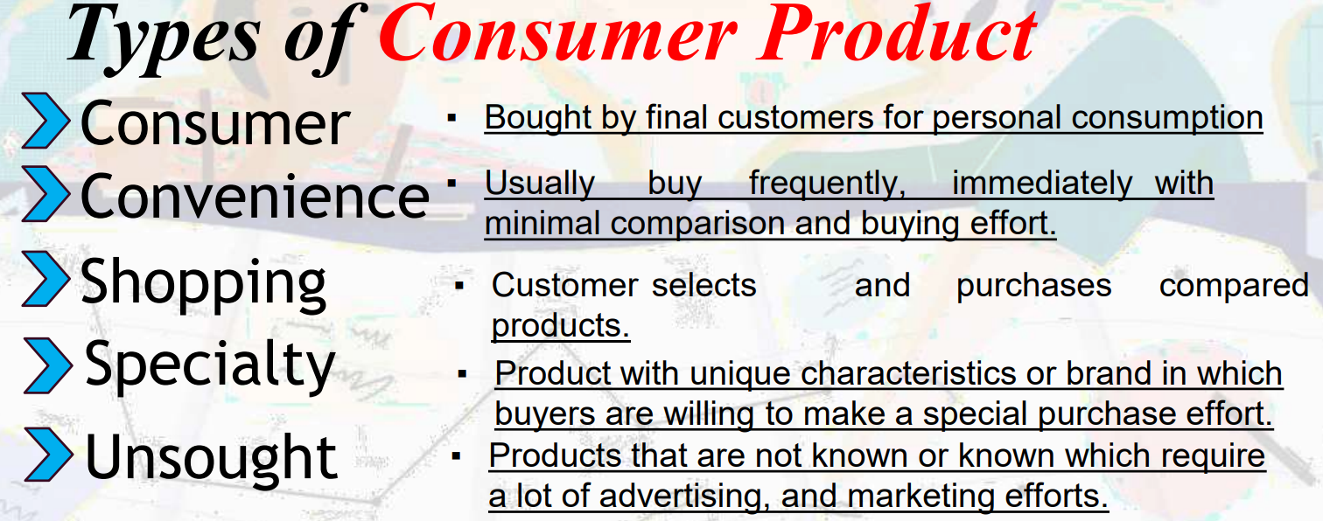

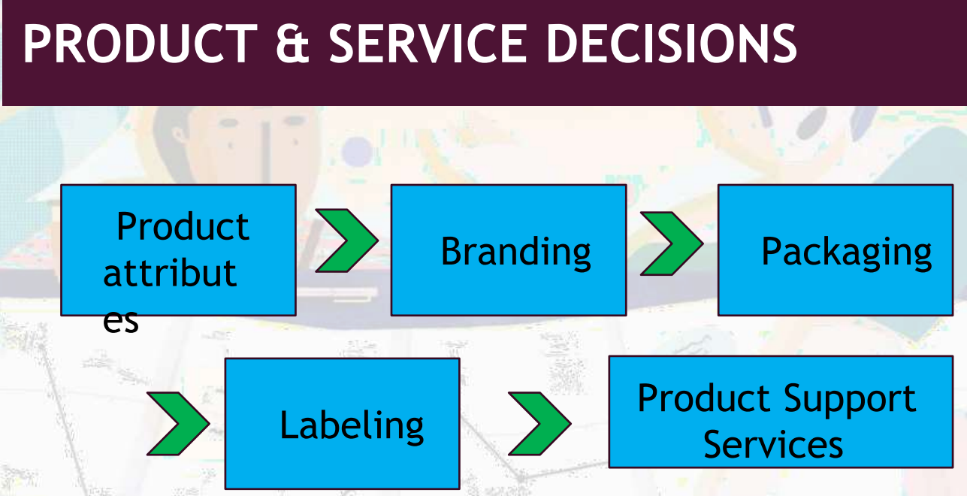

**Product and Service Attributes**

* **Product Quality**. The characteristics of a product or service that bear on its ability to satisfy stated or implied customer needs.
* **Product Features**. This differentiates the company’s product from competitors’ products
* Product style and design

**Branding** - Name, term, sign, symbol, or design, or a combination of these, identifies the products or services of one seller or group of sellers.

**What should a Brand Style Guide include?**

* **Brand Heart**: high-level explanation of your brand’s core principles, which can influence everything from the way you speak to customers.
* **Verbal Identity**: Describe your products, communicate with customers
* **Visual Identity:** Logo, colors, typography, photography, illustration, iconography, data visualization

**Packaging** - Designing and producing the container or wrapper for a product

* Protect the product
* Attract customers and closes the sale

**Labels**

* Identify the product
* Describe the product
* Promote the brand

**Product Support Services**

* After-sale-services
* An important overall brand customer’s experience

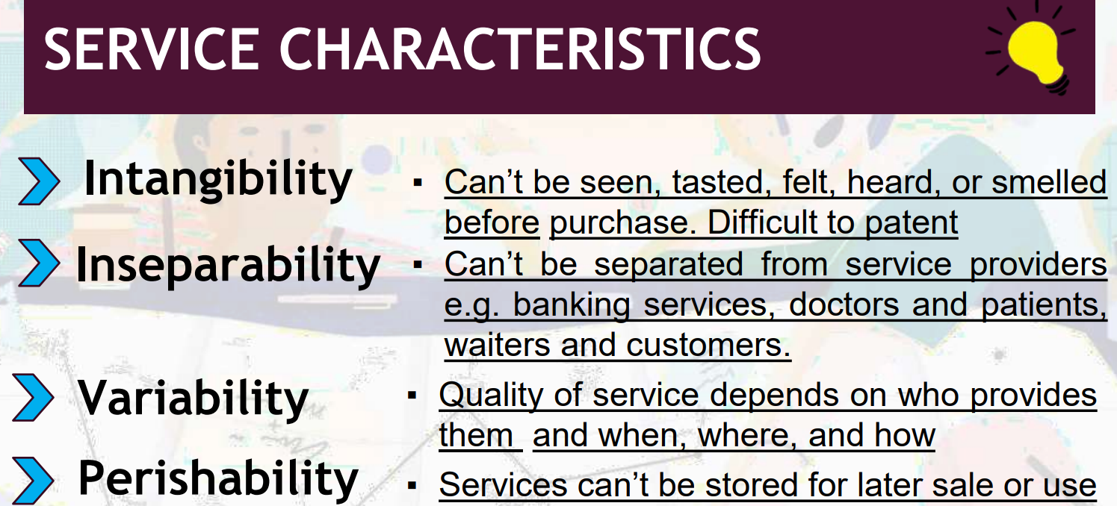

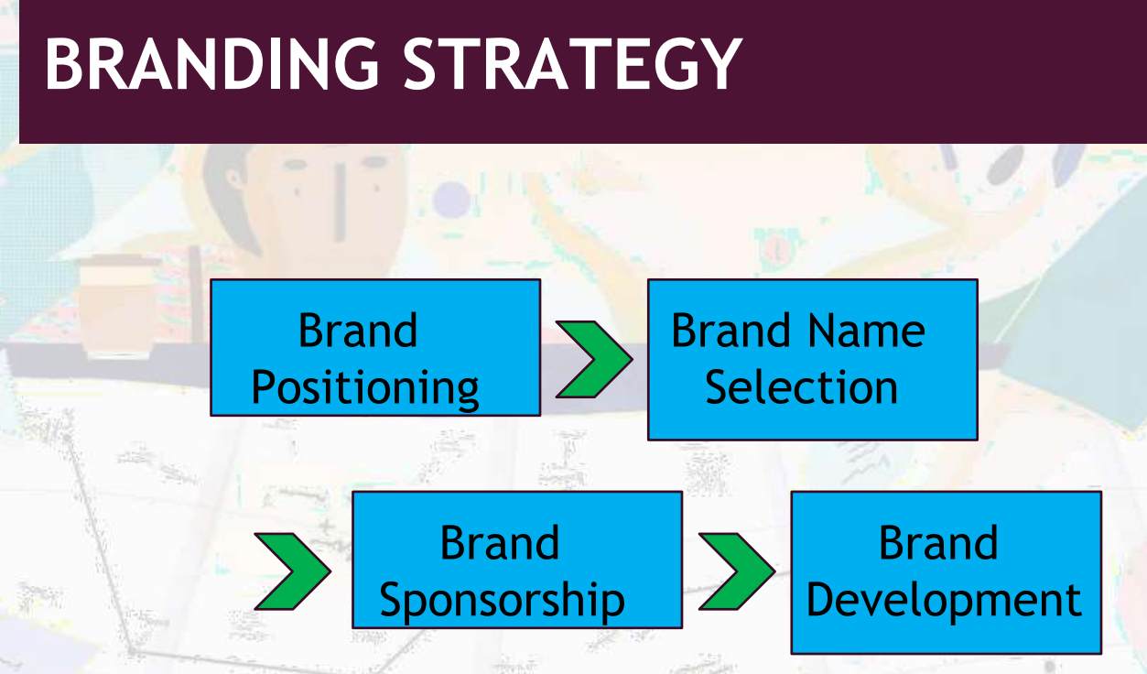

**Brand Positioning** - Marketers can position brands clearly in customer’s minds at any of these three level:

* Production Attributes
* Product Benefits
* Beliefs and values

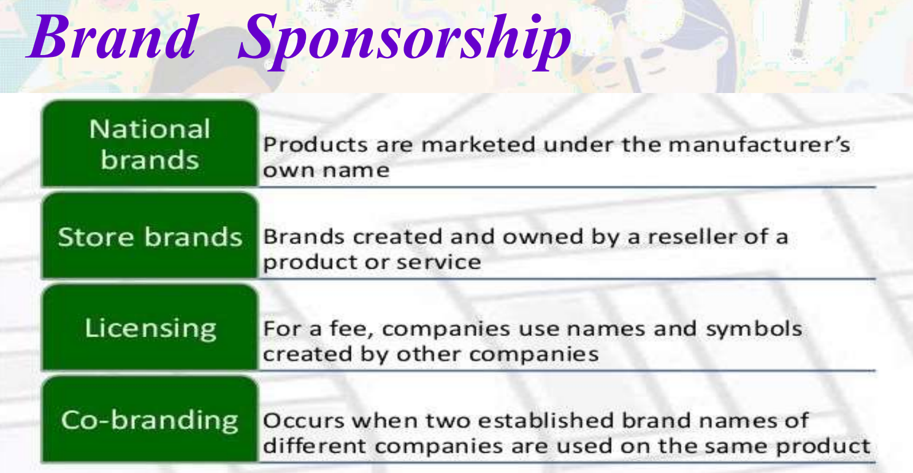

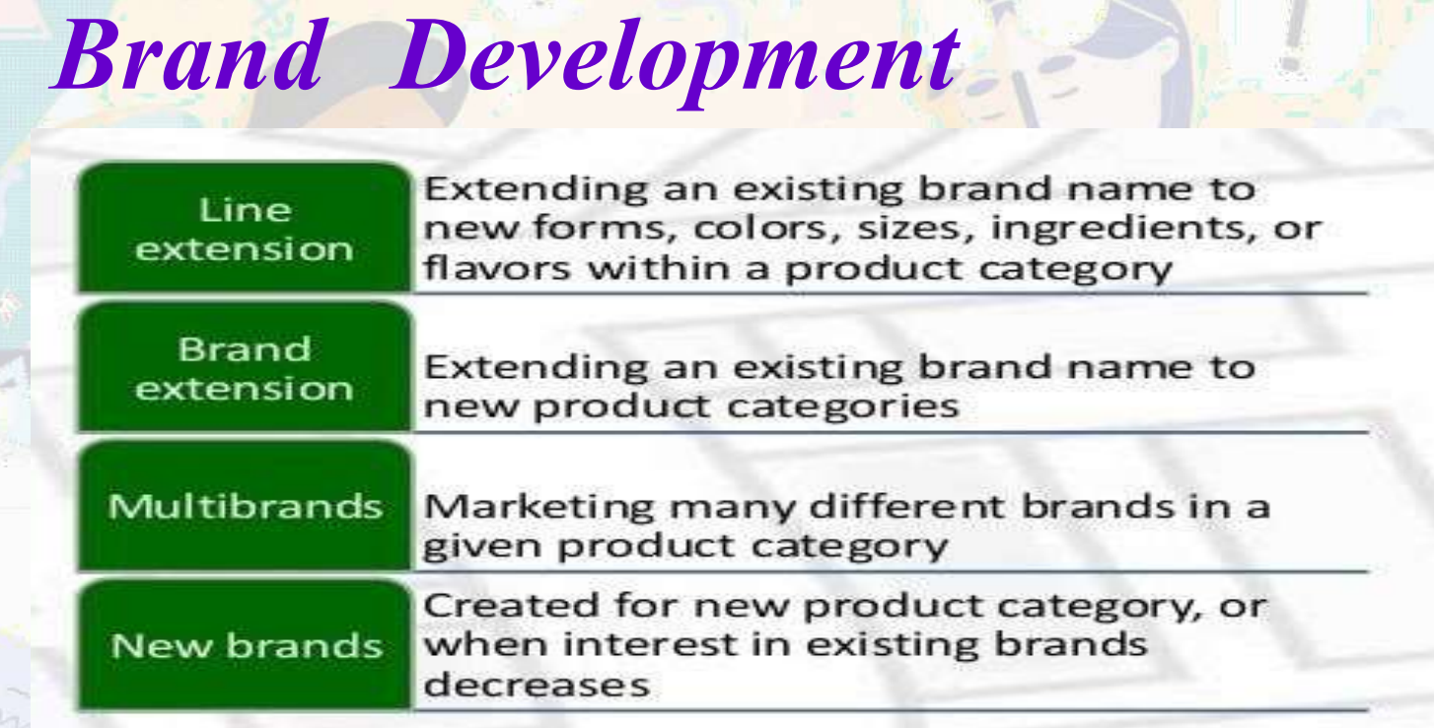

***STRATEGIES FOR NEW VENTURES & MARKETING AS SELLING***

**ENTREPRENEURIAL STRATEGIES**

1. STUDY THE COMPETITION. Know your competitors, the rival product, and services they are offering
2. 2.RESEARCH NEW PRODUCTS AND SERVICES. Understand the products or services in a way that it could improve the operation of the business.
3. DON’TTACKLE HUGE MARKETS AT FIRST. Avoid expanding into large markets at first
4. LISTEN TO CUSTOMER FEEDBACK AND ADAPT.
5. RESPOND TO CHANGE. Be flexible and versatile in responding to change.
6. TRUST YOUR GUT. Trust your instincts to carry out new, untested ideas and venture even if nobody believes in you. When there is a need, do it.
7. BUCK THE CONVENTIONAL WISDOM. Ignore what others will negatively say. Challenging conventions can open the door to competitive advantage
8. NEVER LET ADVERSITY or FAILURE DEFEAT YOU.
9. GO ON A TREASURE HUNT ANDFIND AN UNDERSERVED NICHE.
10. JUST START. Believe that it will succeed.
11. NEVER STOP REINVENTING YOUR COMPANY

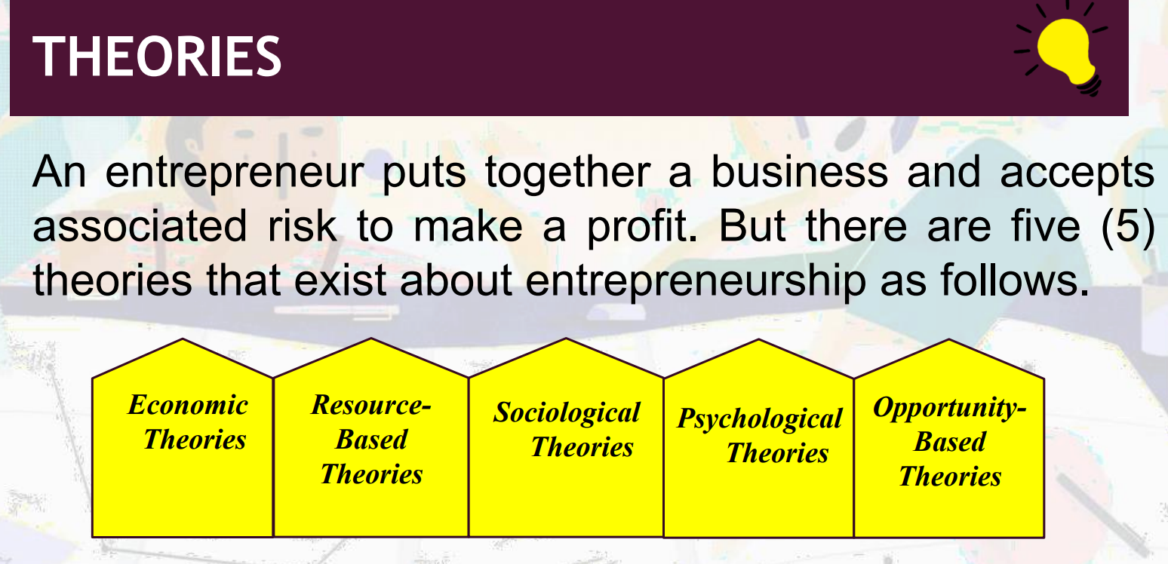

**ECONOMIC THEORIES** - The economic entrepreneurship theories date back to the first half of the 1700s with the work of Richard Cantillon, the idea of entrepreneurs as risk-takers was introduced.

* Economic theories of entrepreneurship tend to receive significant criticism for failing to recognize the dynamic, open nature of market systems, ignoring the unique nature of the entrepreneurial activity and downplaying the diverse contexts in which entrepreneurship occurs

**RESOURCE-BASED THEORIES -** This theory focuses on the way individuals influence different types of resources to get entrepreneurial efforts off the ground

**PSYCHOLOGICAL THEORIES** -This theory focuses on the individual and the mental or emotional elements that drive entrepreneurial individuals. A theory put forward by psychologist David McCLelland, a Harvard emeritus professor, offers that entrepreneurs possess a need for achievement that drives their activity.

**PSYCHOLOGICAL THEORIES** - Julian Rotter, professor emeritus at the University of Connecticut, put forward a locus of control theory. Rotter’s theory holds that people with a strong internal locus of control believe their actions can influence the external world and research suggests most entrepreneurs possess this trait.

**PSYCHOLOGICAL THEORIES**

* High internal locus of control – People believe that they are in charge of their actions and fortune.
* High external locus of control – individuals believe that outcomes are out of their control and completely depends on external factors such as fate, change and others

**SOCIOLOGICAL THEORIES** - This theory centers its explanation for entrepreneurship on the various social contexts that enable the opportunities entrepreneurs leverage. Paul D. Reynolds, a George Washington University research professor, singles out four contexts: social networks, a desire for a meaningful life, ethnic identification and social-political environment factors.

**OPPORTUNITY-BASED THEORIES** Peter Drucker, a prolific business management author, professor, and corporate consultant, put forward an opportunitybased theory. According to him, entrepreneurs excel at seeing and taking advantage of possibilities created by social, technological and cultural changes.

**Marketing Strategy** is a long-term approach and game plan of any organization.

1. **Define your brand value and offering**. Align it with what your prospects and customer find important like industry trends and competitive environment. E.g. promotional videos
2. **Identify customer pain points and expectations**. Meet the customer’s need or they don’t solve a vital problem in their lives. Different types of pain points are Financial, Convenience and Service.
3. **Identify market trends and competition**. Identify what differentiates your product or service from the competition.
4. **Create your value proposition.** Make a business decision about what are you delivering and to whom.
5. **Identify your target audience**. To define your customer, you can use this question list:
6. Who is my customer? Is he a male or female? What age? Name your customer and attach a photo.
7. What is your customer’s initial state of mind? Emotions and thoughts before starting the decision-making process.
8. What are the different stages of his or her decision-making process until purchase?
9. **Identify partners and potential collaborators**. You need to work with a distributor or get a marketing partner to reach them.
10. **Decide on the messaging and creative of your brand**. Just like storytelling. E.g. National Geographic. stunning photography They present and help discover wonders of the world the. They keep the language they use on their ads to be aligned with brand values
11. **Define your marketing channels**. Choose the marketing channels that fit your brand and your product. E.g. for Socialmedia,

* For visual eCommerce products - use Instagram and Pinterest, TikTok, Facebook, Snapchat and Twitter
* For B2B companies - use LinkedIn, Instagram, ProductHunt, and Angellist
* For B2C companies - use Facebook, Twitter, Instagram, Pinterest
* For written content-heavy companies - use Medium, Quora, and Reddit
* For GenZ-focused companies - focus on Instagram, Snapchat, and TikTok

1. **Analyze your results**. Analyze the result and continue testing

***THE INTERNET and FORM OF BUSINESS***

THE INTERNET

Why did Terence Matthews say: “I’m glad I started most of the businesses I have been involved with before the age of the Internet had begun?”

a. Because it was easier back then?

b. Because I am glad I didn’t know what I didn’t know?

The answer is B, because that time he didn’t know that there’s a bunch of competitors out there.

We can understand the importance of internet in business by the inventions Digital Marketing, Internet banking and eCommerce business models. **The internet** is providing great benefits for business communication.

**internet** is now the backbone of an offline business to sell online. And it is the heart for online businesses.

**USE OF THE INTERNET IN BUSINESS**

* Internet is in the role of a business successor. It helps businesses to grow, achieve goals and become successful in this competitive market.

**Reasons To Start An Online Business**

1. It is inexpensive to start. With an online business, all you need is a computer, domain name, and website builder.
2. Major potential and growth. You can sell to anyone, no matter where they live.
3. It can run 24/7. Stay open even in lockdowns.

**How to start an Online Business**

1. Determine your niche and business idea
2. Conduct product research
3. Learn about online business laws
4. Conduct market research
5. Define your target audience
6. Source products to sell online
7. Evaluate and Define your brand and image
8. Launch your online store
9. Grow your business

**Example of Online Businesses to Test Out**

1. eCommerce Store. Buying and selling of goods and services via the Internet, as well as the transfer of payment.
2. Dropshipping. An online fulfillment method that allows to sell physical goods without inventory yourself.
3. Become an affiliate. Start a business online but not interested in creating your own products.
4. Web Design Services. Learn the basics of web design via eLearning platforms and experimentation.
5. Note-worthy blog. Use this to get an audience, then finally sell your own products or services to them.

**Business Organization** - It refers to how a business is structured.

**FORMS OF BUSINESS ORGANIZATION**

**SOLE PROPRIETORSHIP** - Owned by one person

**PARTNERSHIP** - Owned by two or more people

**CORPORATIONS/JOINT STOCK COMPANY** - A joint stock company is a voluntary association of people who contribute money to carry on business.

**CO-OPERATIVE SOCIETY** - Voluntary association of people or business to achieve an economic goal with a social perspective

***FUNDING THE VENTURE, IMPORTANCE OF GOVERNMENT***

**Financial Plan and Source of Fund**

**Funding** is the act of providing financial resources, usually in the form of money, or other values such as effort or time, to finance a need, program, and project, usually by an organization or company (Naik, 2019)

**Why do Entrepreneurs need funds?**

1. To start their business.
2. To run their business.
3. To expand their business.

The **FINANCIAL Plan** - It provides the entrepreneur with a complete picture of The amount of funds and when they are coming into the organization

**Sources of Funding New Entrepreneurs**

1. Personal Source - Borrowing from friends and family. Credit cards
2. Equity Funding - Equity is the ownership of assets after liabilities and debts have been settled or it can refer to stock or ownership of shares in a public company.
3. Bank Loan - It is when a bank offers to lend money to consumers for a certain time period.

TYPES:

* **Secured Bank Loan**. This is a loan that uses an asset as collateral.
* **Unsecured Bank loan**. This is a loan given without any asset for collateral
* **Inter Bank Loan**. Often commercial banks are short of money and so are forced to borrow money on the money markets.

1. Venture Capital - Physical location is important
2. Angel Investor - A person who invests money in a new business to help it get started. It is the opposite of venture capitalists and is also called informal investors
3. Crowd Funding - It is the practice of funding a project or venture by raising a small amount of money from a large number of people, typically via the Internet

TYPES:

* Rewards crowdfunding
* Equity crowdfunding
* Donation crowdfunding
* Lending crowdfunding
* Software value token

1. Government Funding - It is when the government gives an individual or business for a specific project or purpose.
2. Mutual Funding - It is from a company that brings together money from many people and invests it in stock, bonds or other assets.

**Business Regulation in the Philippines**

*First of all, it’s not an option anymore! It’s mandatory!*

The Philippines, with its vibrant economy and strategic regional location, has been pulling significant foreign capital as well as a good number of experts in recent years.

**LEGAL FRAMEWORK**

If a foreign corporation intends to establish a business presence locally, all legal aspects must be considered.

**3 Dimensions of doing business in the Philippines**:

1. Qualifications of the foreign enterprise to formally enter the economy
2. Amenability to suit of a foreign corporation
3. Tax treatment of the foreign enterprise

**BOI** – is the main agency in charge of investment promotion in the country.

Location and eligibility of activity are the two main qualifications to be able to register with **PEZA.**

**PHILIPPINE GOVERNMENT AGENCIES**

**BUREAU OF INTERNAL REVENUE (BIR**)– responsible for assessment and collection of all internal revenue taxes, fees, and charges

**SOCIAL SECURITY SYSTEM (SSS**)– all employees working for private companies must apply to be SSS members. The purpose is to protect the members in case of inability to work due to sickness, disability, maternity, old age, death, and other contingencies.

**PHILHEALTH–** all employees are required to be contributors of the Philippine Health Insurance Corporation, the medical insurance company of the Philippines

**HOME DEVELOPMENT MUTUAL FUND**– on behalf of the employers are required to contribute to the Home Development Mutual Fund also known as the Pag-Ibig Housing Development Program

* It provides the opportunity to own a house and lot in easy payment

**BUSINESS REGISTRATION**

1. For a single proprietorship, the business should apply for a business name and get registered with the Department of Trade and Industry (DTI).
2. For partnerships or corporations, a certificate of registration must be obtained from the Securities and Exchange Commission (SEC).
3. For cooperatives ,the business must register with the Cooperative Development Authority (CDA)

**OWNERSHIP LAND/REAL PROPERTIES IN THE PHILIPPINES BY foreign investors/corporations**

* Foreign companies and investors can acquire lands as long as these are privately owned, and foreign equity doesn’t surpass the 40% capitalization.

***BUSINESS PLAN***

CONTENTS OF BUSINESS PLAN

⮚Cover - This serves as the title page of your plan.

⮚Statement of Purpose (Mission statement) - Also known as executive summary. Name and nature of your business, legal structure, amount and purpose of your loan request and your plan for repayment.

⮚THE BUSINESS -

▪ Legal Structure - State the reasons for your choice of legal structure. If you are a sole proprietor, you may include a copy of your business license.

▪ Description of the Business- This is the section of the plan in which you go into greater detail about your business. Answer the keyword questions regarding the business’s history and present status, and your future projections for research and development.

**CONTENTS OF BUSINESS PLAN**

* Products or Services - Give a detailed description of your product from raw materials to finished items.
* Locations - If location is important to your marketing plan, you may focus on it in the marketing section.
* Management - This section describes who is behind the business. If you are a sole proprietor, talk about your abilities and include your resume.
* Personnel - Who will be doing the work? Why are they qualified? How will they be hired? What is their wage? What will they be doing? Outline the duties and job descriptions for all personnel.
* Methods of Record Keeping - Tell what accounting system will be used and why the system was chosen. Who will be responsible for keeping those records?
* Insurance - Insurance is an important consideration for every business.
* Security - Address the issue of security as it relates to your business.

**MARKETING**

* Target Market - Tell how you did your market research.
* Competition - Direct competition is a business offering the same product or service to the same market. Indirect competition is a company with the same product or service but with a different target market.
* Methods of Distribution - Distribution is how products are physically transported to the consumer or the way services are made available to the customer.
* Advertising - Advertising presents the message to your customer that your product or service is good and desirable.
* Pricing - Your pricing structure is critical to the success of your business and is determined through market research and analysis of financial considerations.
* Product Design - Packaging and product design can play a major role in the success of your business. It's what first catches the customer's eye.
* Timing of Market Entry - The timing of your entry into the marketplace is critical and takes careful planning and research
* Location - If your choice of location is related to your target market, cover it in this section of your business plan
* Industry Trends - Be alert for changes in your industry. New technology may bring new products into the marketplace that will generate new service businesses

**FINANCIAL DOCUMENTS**

* Summary of Financial Needs - If you are applying for a loan, your lenders and investors will analyze the needs of your business. They will distinguish among the three types of capital to be used as follows:
* **Working capital** -- Used to meet fluctuating needs that are to be repaid through cash during the business's next full operating cycle, generally one year.
* **Growth capital** -- Used to meet needs that are to be repaid with profits over a period of a few years.
* **Equity capital --** Used to meet permanent needs.

Sources and Uses of Funds Statements - **USES OF FUNDS** - The potential lender will require a statement of how the money you intend to borrow will be used.

* Cash Flow Statement (Budget) - Cash flow statements are the documents that project what your business plan means in terms of peso. They show cash inflow and outflow over some time and are used for internal planning

Two worksheets can be used in developing a cash flow statement:

**- Sources of cash workshee**t -- Contains all the financing sources for the business.

- **Cash to be paid out worksheet** -- Identifies how much cash is expected to be spent to pay expenses and obligation

* Three-year Income Projection Supporting Documents - The three-year income projection is a pro forma income statement. The difference is that the three-year projection only includes income and deductible expenses while the cash flow statement includes all sources of cash and cash to be paid out.